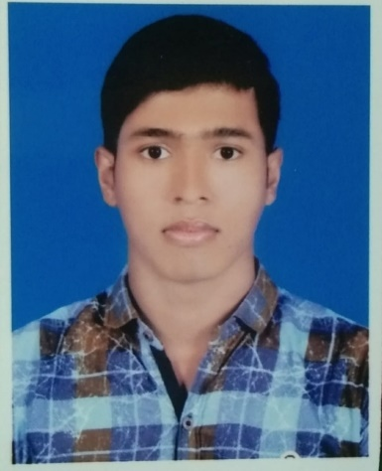**Curriculum Vitae**

**OF**

**Pallab Bachhar**

**Mailing Address:**

Farmgate

Tejgaon, Dhaka.

Contact no: 01903-461145

E-mail: pallabbachhar851@gmail.com

|  |
| --- |
| **OBJECTIVE:** |

I would like to develop my career in civil engineer where I will get the opportunity to explore and extend my knowledge and skill. I want to work any challenging job where I can serve the development efficiency to achieve its goal.

**Professional Experience: Running**

1. Now l am working as site engineer at" CROSS-WORLD ABO- AMIN . Here l am following metro rell 10 no Station our all kind of construction work, billing & estimate (10-05-2022 to till now)

|  |
| --- |
| **EDUCATIONAL QUALIFICATION** |

|  |  |  |  |  |  |
| --- | --- | --- | --- | --- | --- |
| **Name of**  **exam** | **Year of**  **Passing** | **Board /**  **University** | **Institute Name** | **Group** | **Result** |
| S.S.C | 2017 | Jessore | Bayarbhanga Biswambar High School | Commerce | 3.73  (Out of 5) |
| Diploma in  Engineering | 2021 | BTEB | Sundarban Institute Of Tecnology | Civil | 3.68  (Out of 4) |

|  |
| --- |
| **TRAINING SUMMARY** |

Training Title : Attachment

Topics : Basic of civil, site visit and auto cad 2d.

Institute : PWD division - 1.

Country : Bangladesh

Location : Boyra, Khulna.

Duration : 3 months (2019)

|  |
| --- |
| **SKILLS:** |

* Microsoft Office
* Internet
* E-mail
* Auto Cad 2D
* 2.5 year experience masonary, plumbing, house wiring .

|  |
| --- |
| **MY ABILITY:** |

* Can work under pressure.
* Can learn quickly
* Friendly behavior
* Enthusiastic confident
* Speaking of English

|  |
| --- |
| **PERSONAL INFORMATION:** |

**Name : Pallab Bachhar**

Father's Name : Tapan Bachhar

Mother's Name : Gayatree Bachhar

Permanent Address : Vill: Balabunia, P.O: Bayarbhanga,

S.D Batiaghata, Dist: Khulna.

Present Address : Farmgate, Tejgaon, Dhaka

Date of Birth : 23th July , 2000.

Nationality : Bangladeshi

Religion : Hindu

Marital Status : Unmarried

Gender : Male

Blood Group : B+ve (Positive)

Contact : 01903-461145

|  |
| --- |
| **DECLARATION:** |

I the undersigned certify that according to my knowledge and belief, this CV correctly describes my qualification, my experience and me. I understand that any willful misstatement here may lead to my disqualification or dismissal, if employed.

Applicant’s Signature

**Pallab Bachhar**

**Date: ......../......../.............**